Technical Report: Urban Crash Risk Radar





Contents
Urban Crash Risk Radar 2
Executive Summary 2
Technical Report 3
Highlights of Project 3
Abstract 4
Methodology 8
Results 13
Discussion 18
Conclusion 21
Contributions/References 22

Urban Crash Risk Radar

Executive Summary
This data engineering project aimed to provide users with a practical, simple-to-use web application displaying the likely locations of car crashes across five major US cities. Business applications include the possible targeting of high-risk traffic regions for infrastructure improvement, the tailoring of insurance premiums based on geographic locations, and the improved safety of navigation in urban landscapes. Relying on Amazon Web Services Learner Lab predominantly, this project was able to successfully ingest, store, process and consume data, delivering a polished web application allowing users to easily view the likely locations of car accidents based on rich historical data.
Team Members:  Alima Aqsai  Ellen Martin  Rohan Vibhuti | Questions?  Contact:  alimaaqsai1@gmail.com  martin.ellenjane@gmail.com  rohanvibhuti666@gmail.com
Submitted On:
Word Count: 2,593

Technical Report
Urban Crash Risk Radar | 

Highlights of Project
- Completed using free tier products (AWS Learner Lab, Vercel, Python)
- Accurate and interpretable Machine Learning model predictions
- Minimalistic, practical user interface addressing business questions immediately
- Reproducible and scalable engineering pipeline for future expansion and scheduled data ingestion

Abstract
Car crashes are the eighth leading cause of death worldwide, according to the World Health Organization. Understanding where fatal car accidents are more likely to occur may enable policymakers to act in preventing further loss of life caused by car crashes, as well as in preventing the economic consequences of road accidents. This project therefore aimed to deploy an interactive web application, allowing users to view heatmaps illustrating the likely locations of car crashes in five major US cities.
Fifty years of public data from the National Highway Transport Safety Administration (Department of Transportation) were ingested and stored in parallel using a Python script, implemented within an Amazon Web Services (AWS) Elastic Compute Cloud (EC2) instance, and stored in an AWS Simple Storage Service (S3) bucket. Processing (extraction, transformation and loading) were performed using a PySpark script implemented in AWS Glue. This script extracted relevant datasets, handled missing data, standardized schema for model training, and stored data in Parquet format in the S3 bucket. Finally, XGBoost machine learning models were trained using data from 2016 - 2023 to predict latitude and longitude of likely car crashes, stored in GEOjson format in the S3 bucket, to be rendered as heatmaps on a static webpage using Vercel.
This project successfully implemented a reproducible, reliable and scalable data engineering pipeline, supported using Python and AWS. We deliver a minimalistic and practical web application that enables users to interactively examine the likely locations of car crashes based on historic data for five major cities in the US. Opportunities for future development include expanding the available range of cities users can select for queries, the scheduled ingestion of annually released, and expansion of this pipeline to other nations’ traffic accident data.

Introduction
Traffic-related deaths are a growing concern in many U.S. cities. In 2023 alone, more than 41,000 people died in crashes, with many of these tragedies happening in big cities like Memphis, Detroit, and Jacksonville (Masud et al., 2024). Problems such as poor road infrastructure, inadequate lighting, distracted driving, and insufficient public safety funding all contribute to the risk. To tackle this, researchers and policymakers are turning to new, data-driven tools to spot risks and prevent accidents before they happen. Unlike traditional approaches that react to crashes after they occur, advances in machine learning (ML), geospatial analytics, and cloud-based computing now make proactive road safety management possible (Marcillo et al., 2022).
The Urban Crash Risk Radar follows this new direction by bringing together geospatial data, local population information, environmental data, and decades of crash records to identify where deadly accidents are most likely to occur. The project uses 50 years of traffic data from five major U.S. cities and applies advanced machine learning to spot patterns that lead to fatalities. National studies show that places like California, Texas, and Florida have had some of the highest fatality rates for years (United States Road Accident Prediction using Machine Learning, 2025).
Despite all this research, a few models still use local city data to predict crash risk in specific urban areas. This project aims to solve that problem by building a cloud-based Urban Crash Risk Radar that predicts where deadly accidents are likely to occur across multiple cities and displays the results in an interactive geographic heatmap. The goal is to empower planners, policymakers, and traffic authorities to make smarter, data-driven decisions to prevent crashes and save lives.

Literature Review
Research on traffic accident prediction has grown rapidly over the past decade, as new tools like machine learning (ML), deep learning (DL), and geospatial analytics have become more widely used. Early studies relied on traditional statistical models, but recent approaches increasingly use ML to capture the complex, nonlinear relationships between variables such as road design, lighting, weather, and driver behavior (Marcillo et al., 2022). Masud et al. (2024) showed that poor lighting, sharp curves, and risky driving are particularly important predictors of severe accidents. They emphasized the value of explainable ML models that clarify which factors have the most significant impact. Marcillo et al. (2022) also showed that combining traffic, weather, and urban design data yields stronger and more accurate predictions, laying the groundwork for city-level crash risk mapping.
Building on these ideas, Karimi Monsefi et al. (2024) developed CrashFormer, a deep learning model that combines images, text, and sensor data to create detailed maps of crash risk in cities. Their work shows that combining different types of data helps predict crashes better in busy urban areas. On a larger scale, the United States Road Accident Prediction using Machine Learning (2025) study analyzed crash data from across the country and found that big cities often have the same trouble spots year after year, underscoring the importance of local models. However, most past research has focused on just one city at a time, making it hard to apply those models elsewhere. A model that works in one city might not work in another because of differences in roads, weather, or driving habits. This means there are only a few systems that can accurately predict crashes across multiple cities or handle large amounts of historical data simultaneously.
The Urban Crash Risk Radar is designed to close this gap. It brings together 50 years of crash data from five major U.S. cities into one cloud-based system. Building on the ideas of Karimi Monsefi et al. (2024), the project responds to the call for local models in the United States Road Accident Prediction (2025) study. By using a scalable machine learning framework and interactive maps, this project tests whether a single system can work across different cities to delivering city-specific predictions of the likely locations of fatal car accidents, and help policymakers improve road safety and prevent future crashes.

Methodology
Data Source

The Urban Crash Risk Radar leverages nation-wide car crash data from the National Highway and Transport Safety Administration (NHTSA), a subsidiary of the Department of Transportation. Data collected between the years of 1975 - 2023 are available for public access from the Fatal Accident Reporting System (FARS): https://www.nhtsa.gov/file-downloads?p=nhtsa/downloads/FARS/.
A full user manual is also provided, including full specification of variables available for analysis (National Center for Statistics and Analysis, 2025).

Data Engineering Tools

The table below lists the full set of tools used to set up data engineering pipelines for the Urban Crash Risk Radar. The entire pipeline is executable using Amazon Web Services (AWS) Academy Learner’s Lab, making it free for academic institutes.

Table 1. Full set of tools used for the data engineering pipeline

Tool | Description | Usage
Amazon Web Services (AWS) Simple Storage Service (S3) | Scalable cloud-storage | - Storing scraped raw data  - Storing processed data  - Storing model predictions
Amazon Web Services (AWS) Elastic Compute Cloud (EC2) | Cloud computing resources | - Powering batch ingestion of large-scale raw data  - Powering Extraction, Transformation and Loading (ETL)  - Powering model-training
Python (pandas, geopandas, scikit-learn, boto3, PySpark) | Programming language | - Parallelized ingestion scripts  - ETL scripts  - Spark integration  - Model training
Amazon Web Services (AWS) Glue | Serverless data integration service. | - Extraction, Transformation and Loading (using PySpark script)
Leaflet.js | Javascript library for interactive maps | - Visualizing machine learning model predictions
Tailwind CSS | CSS Framework | - Minimalistic user interface and graphical display
Vercel | Shipping web apps | - Hosting static web app

Data Ingestion

We used parallelized batch processing to ingest fifty years of static historical data from the NHTSA-FARS database. Using Python, a multi-threaded ingestion script was used to access the web location of each zip file containing all datasets for a specific year. A multi-threaded approach drastically speeds up the ingestion of large amounts of data through parallelization, downloading zip files in memory, and uploading them to cloud storage. The advantages of this approach are that zip files do not get stored on the machine's local storage but are instead immediately stored in the cloud. An AWS EC2 (t4.small) instance was used to support the running of the multi-threaded ingestion script.

Data Storage
The Urban Crash Risk Radar uses Amazon Web Services (AWS) S3 buckets to store raw and processed data. AWS S3 was selected as the storage solution given its high durability, low cost, and seamless integration with the AWS data processing ecosystem. This service is well-suited for hosting the project's datasets, which consist of annual CSV files of approximately 30,000 rows each.
Data Extraction, Processing, Transformation & Loading
The NHTSA-FARS zip files contain several csv files that are not used by the Urban Crash Risk Radar, which uses only the accidents.csv file in each year’s folder. A PySpark script, implemented in AWS Glue, handled data extraction, as well as subsequent data transformations using batch processing. Processing included handling null values, selecting data and cleaning data stored as a pandas data frame, followed by subsequent conversion into a spark data frame for vertical concatenation/unionization of data from all years. Finally cleaned, structured data was stored in Parquet format for consumption by machine learning models.
Consumption
Following data cleaning and preprocessing, two XGBoost machine learning models were trained to predict Latitude and Longitude for each of the five cities (i.e., Los Angeles, Houston, Detroit, Dallas and Memphis). Here, we implemented a Python script within an EC2 instance. To account for the cyclical nature of features like date and time, a cyclical encoder was used to transform appropriate features into sin/cos format. For example, for the “Hour” feature, this means that 24, corresponding to 11:00 am is treated as being close to 1, corresponding to 1:00 am, given that they are only two hours apart, rather than being treated as 23 hours apart. 15 features were specified as predictors, shown in the table below alongside outcome variables and filtering variables.

Table 2. Full list of selected, transformed, engineered and predicted features for XGBoost machine learning model training

Feature Name | Data Type | Description
Hour | Numeric 0-24 (cyclical) | Transformed using cyclical encoder.
Month | Numeric 1-12 (cyclical) | Transformed using cyclical encoder.
Day of Week | Numeric 1-7 (cyclical) | Transformed using cyclical encoder.
Day of Month | Numeric (cyclical) | Transformed using cyclical encoder.
Functional System | Categorical (1-7) | Interstate, Principal Arterial, Minor Arterial, Major Collector…
Route | Categorical (1-6) | Interstate, U.S. Highway, State Highway, County, Township, Municipal
Road Owner | Categorical (1-4) | State Highway, County highway, Town or township, City or Municipal
Related Junction | Categorical (1-8) | Non-Junction, Intersection, Intersection-Related, Entrance/Exit Ramp-Related, Driveway Accident, Railway Gated…
Road Name | Categorical (1-4) | Specific roadway (e.g., I-65)
Intersection Type | Categorical (1-3) | Not an Intersection, Four-way Intersection, T-Intersection,
Related Road | Categorical (1-5) | On roadway, On median, On roadside, Outside trafficway…
Weather | Categorical (1-10) | Clear, Rain, Snow, Fog, Cloudy…
Light Conditions | Categorical (1-5) | Daylight, Dark (Unlit), Dark (Lit), Dawn, Dusk
Rush Hour | Binary | Engineered feature (weekdays 7-9 am & 4-6 pm) using Day of Week and Hour columns.
Bad Weather + Dark | Binary | Engineered feature (not daylight and not clear weather) using Light Conditions and Weather columns.
Latitude | Numeric | Response variable
Longitude | Numeric | Response variable
City Name | String | Used for filtering models by city and state.
State Name | String | Used for filtering models by city and state.
Year | String | Appended to data for user filtering.

Models were trained based on 1, 3, 5 and 8 years of data, splitting the joined data into 80% training sets and 20% test sets. The evaluation method for machine learning models was the Mean Absolute Error (MAE), which was stored alongside the final sample sizes in subfolders of the AWS S3 bucket. Predicted latitudes and longitudes were converted into a GEODataFrame, then stored as GEOjson format for later visual heatmap display using the standard WGS84 coordinate system.
Deployment
Vercel was used to host a static webpage, allowing users to select a city from a drop-down menu, as well as how many years of data they wanted to view heatmaps based on (i.e., 1, 3, 5 or 8 years). Leaflet.js was used to render GEOjson data as a visual heatmap that users can interact with.
Documentation & Reproducibility
To facilitate collaboration, reproducibility and transparency, a GitHub repository was initialized, containing all scripts implemented in the full data engineering pipeline and project documentation. The GitHub repository is available at: https://github.com/vibhutirohan/Urban-Crash-Risk-Radar

Results
The final data engineering pipeline architecture is shown in Figure 1, demonstrating successful ingestion of raw data using EC2 and a Python script, ETL using PySpark in AWS Glue and storage in Parquet format, the training of machine learning models using Python and EC2, and the serving of interactive heatmaps on a static webpage, hosted on Vercel.
Figure 1. Final data engineering pipeline architecture.

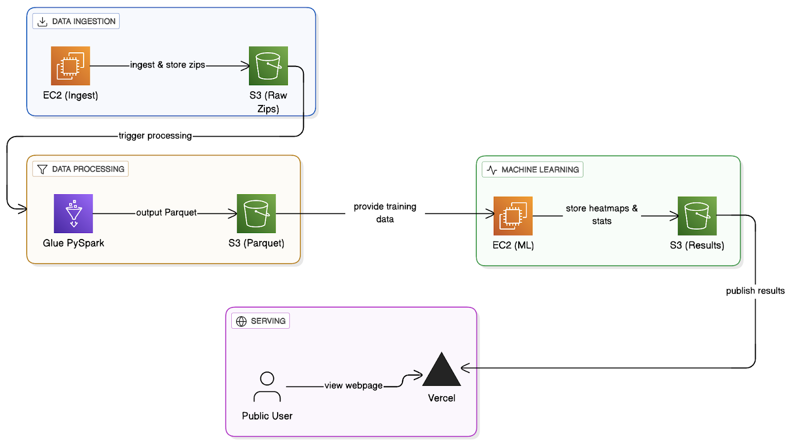

We successfully deployed a static web-based application displaying the likely locations of (fatal) car accidents in five major U.S. cities at this web address: https://urban-crash-risk-radar.vercel.app/.The website contains instructions on how users should use the application, though even without instructions, the app’s intuitive and minimalistic front-end design makes it simple to use. Because this app pulls from precomputed model predictions and pre-generated heatmaps stored in AWS S3, there is no latency, making the application highly responsive.
Figure 2. Interactive heatmap hosted on the Crash Risk Radar application

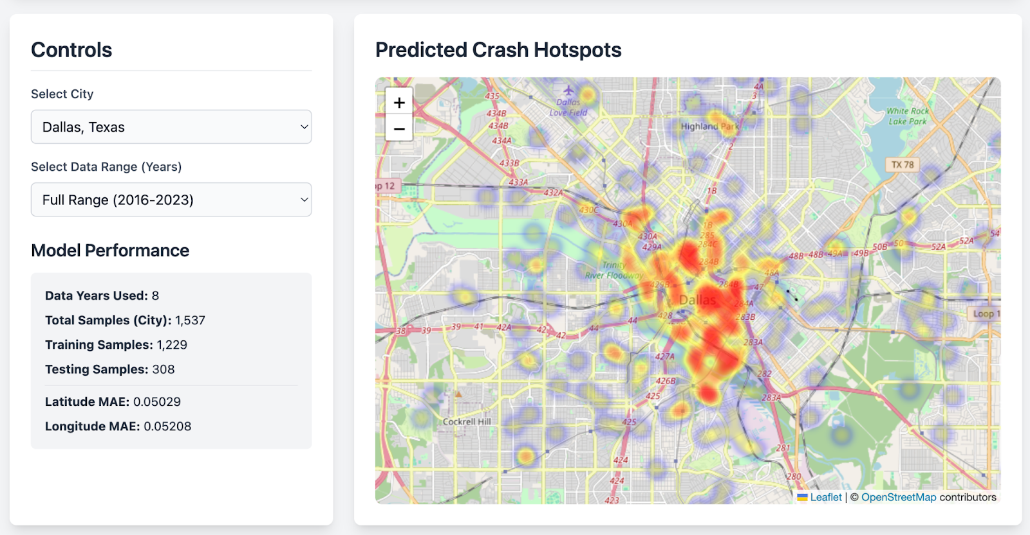
Note. This user has selected Dallas, Texas, and the full range of data for modelling (2016-2023). Users can specify different cities by using the drop-down boxes in the Controls section.
Figure 2 displays a section of the web-app showing the interactive heatmap, user controls and model performance. By zooming in, users can view the locations of potential future crashes with more precision, shown in Figure 3 below.

Figure 3. Heatmap zoomed in demonstrating more precise accident locations
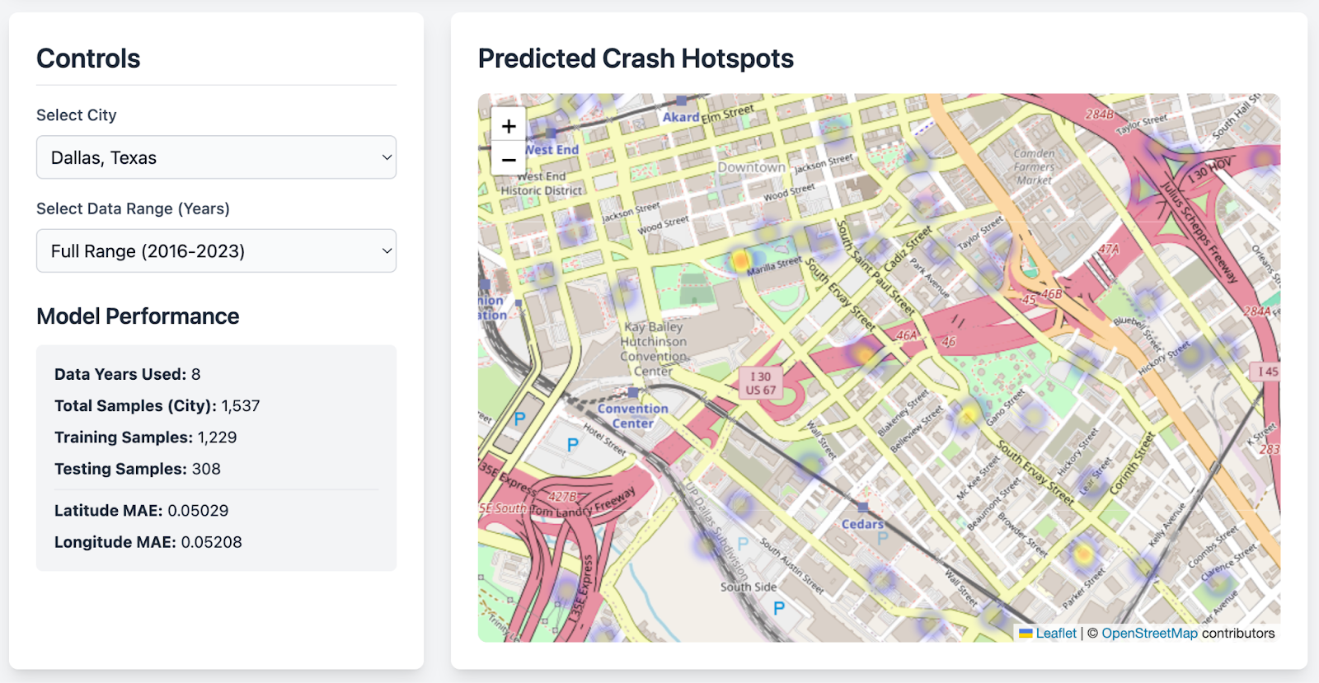
Note. The heatmap appears fainter, given the spread of geographic locations. The intensity of the heatmap also varies with the likelihood of a car accident, with more intense red representing a greater likelihood of an accident in that location.
Model performance indices are also clearly available to viewers, essential for real-world interpretation of the heatmaps. The website also offers users with information regarding the dataset used for model predictions, as well as how to interpret the MAE model fit index, shown in Figure 4 below.

Figure 4. Bottom section of the web application providing users with further information

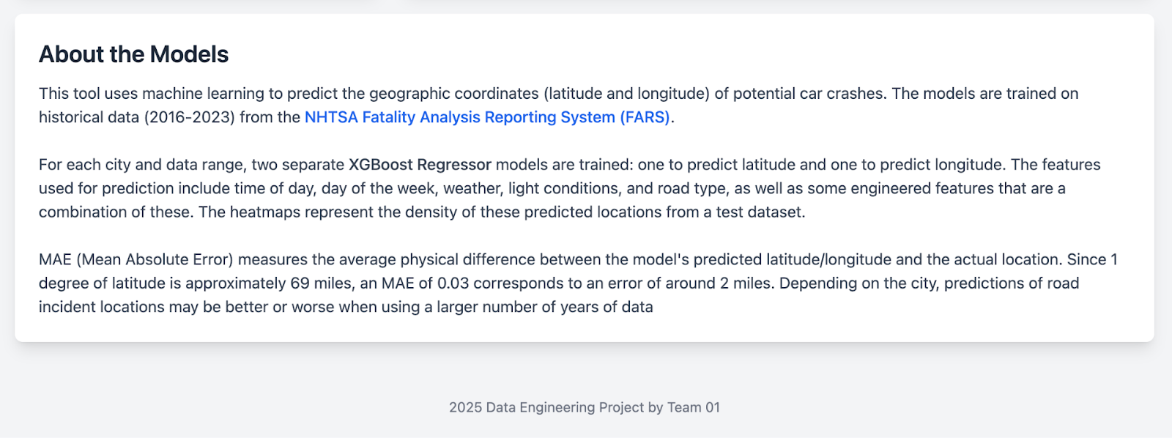

The use of tailwind.css also enables responsive rendering on smartphone displays, enabling greater access to the application. A sample screenshot is shown in figure 5 below.

Figure 5. Screenshot of rendering on an IOS mobile device

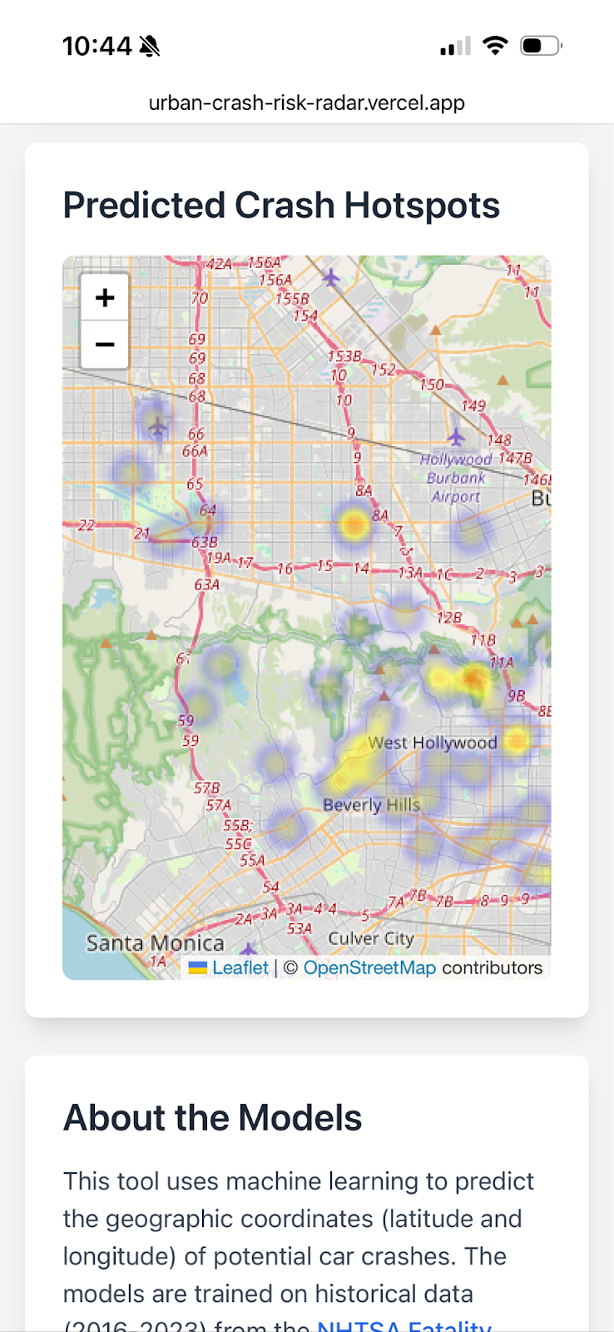
Note. This screenshot shows a section of the full webpage, responsive on an IOS mobile web browser.

XGBoost Machine Learning models performed well overall, though model performance depends largely on city selection. For Houston, TX, the best performing model was based on 3 years of data, and 728 training samples (Latitude MAE = 0.061, Longitude MAE = 0.084), providing accuracy within a 6- to 8-mile radius. For Los Angeles, CA, models trained on 5 years of data, and 1,212 training samples were the strongest (Latitude MAE = 0.067, Longitude MAE = 0.064), providing accuracy within a 6-mile radius. For Detroit, MI, models performed similarly across all date ranges, outperforming many other models for latitude prediction, even when based on just one year of data, and 98 training samples (Latitude MAE = 0.03, Longitude MAE = 0.091). This suggests that the model was able to accurately predict latitude within a 2-mile radius. To view all MAE indices, refer to the indices displayed on the web application.

Discussion
This project successfully delivered predicted locations of car crashes in five major US cities using a web application. This project relied only on free data engineering pipeline architecture, including the Amazon Web Services (AWS) Learner Lab, Python, and Vercel.
Using a multi-threaded Python script and parallel processing with AWS Elastic Compute (EC2), we were able to rapidly ingest 50 years’ worth of national data pertaining to annual car crash fatalities. All data was successfully stored on an AWS Simple Storage (S3) bucket. This initial storage enabled us to efficiently extract, transform and load datasets for the cities queried within this project. Furthermore, initial ingestion and processing scripts were programmed dynamically, allowing for future scaling and ingestion of new data when they become publicly available, a key cornerstone of high-quality data engineering pipelines.
One hurdle we encountered during data processing was that many of the older datasets did not follow a standardized schema. Specifically, datasets prior to 2016 did not include many of the columns selected as key features for XGBoost machine learning models. Consequently, we were unable to use data before 2016 to generate machine learning model predictions. This limitation thus highlights the importance of schema consistency and encourages organizations that collect large quantities of data to ensure adherence to schema in the future. In this project, however, the Mean Absolute Error indices shown to users on the web application suggest that using a larger number of years to train models does not necessarily result in increased accuracy. Additionally, as road layouts can change considerably in the span of 50 years, it is highly likely that road conditions from the earlier years do not match current road conditions, meaning that predictive models may not be entirely useful for predicting likely future road accidents. While schema consistency is a fundamental for future analyses, it did not prevent this project from generating accurate and useful machine learning model predictions.
A key strength of our data consumption approach is that we pre-trained machine learning models for all possible combinations of cities and year-ranges. This means that 20 separate predictions were generated, corresponding to the total possible city-year combinations. By pre-computing these, rather than computing them in real-time per user request, we avoided long periods of latency and delay, improving the user-experience of the web application, while also avoiding the complexity and costs associated with real-time model training on datasets of this scale. Implementing real-time model training is, however, a possible future extension of this project, but for the purpose of remaining within AWS free tier of services, we selected a simpler engineering pipeline that was able to achieve the same goal more efficiently. Indeed, an even more ambitious extension of this project could involve the incorporation of real-time streaming data from, for example, traffic surveillance or satellite imaging, allowing predictions to integrate both historic traffic patterns with real-time road dynamics.
An additional future development of this project could be to schedule ingestion of data from the NHTSA-FARS data source annually, allowing new model predictions to be generated based on data from 2024, which is not yet available, and eventually, on data from 2025. Our Glue PySpark script is designed to handle slight variations in schematic specifications, such as minor differences in column names and varying lengths of data frames. Additionally, the scripts for machine learning models are entirely dynamic, meaning that the exact same modelling scripts can be re-run and will automatically incorporate the new year(s)’ worth of data into machine learning model predictions. Likewise, the static web application is designed to pull data from the (updated) AWS S3 bucket, and will automatically update visual heatmaps with newest predictions, without needing to alter the script in any way. Overall, the reproducible and dynamic design of our data engineering pipeline directly facilitates the incorporation of future data with minimal effort, making it extremely practical for policymakers who will not be required to make changes to the data engineering pipeline or any scripts.

Conclusion
In this project, we have successfully implemented a low-cost, reproductible, scalable and reliable data engineering pipeline. The primary objective of implementing this pipeline was to deliver users with the predicted locations of likely fatal car accidents, based on machine learning models trained on years of historical data, delivered in the form of an interactive geographic heatmap.
We deployed a web-based application, allowing users to select, out of five major cities, which city to query, and based on a selection of available years (i.e., 1, 3, 5 or 8 years of data). This web application is simple to use, whether a user has a technical or non-technical background. By also delivering model performance measures, we allow users to understand how best to interpret visual heatmap results, ensuring that it has practical business applications in the sectors of infrastructure development, road safety, and insurance.
There are several opportunities for scaling this project, such as expanding the list of cities users can view model predictions for, and potentially integrating live, streaming data from traffic surveillance cameras and satellite data to improve real-time model predictions. Ultimately, we were able to produce a data engineering product serving users with actionable insights for improving road traffic safety, with the potential to prevent the economic consequences of traffic accidents and, more importantly, the potential to prevent unnecessary human harm.

Contributions/References

Karimi Monsefi, H., Etemad, A., & Shafiee, M. J. (2024). CrashFormer: Multimodal Transformer Network for Road Crash Risk Prediction. IEEE Transactions on Intelligent Transportation Systems, 25(6), 5432–5444. https://doi.org/10.1109/TITS.2024.3351725
Marcillo, S., Xie, Y., & Wang, T. (2022). Machine Learning Applications for Traffic Accident Prediction: A Systematic Review and Meta-Analysis. Accident Analysis & Prevention, 171, 106727. https://doi.org/10.1016/j.aap.2022.106727
Masud, M., Alhumyani, H., & Hossain, M. S. (2024). Factors Influencing Fatal Road Accidents: An Explainable Machine Learning Approach. Applied Sciences, 14(14), 6378. https://doi.org/10.3390/app14146378
National Center for Statistics and Analysis. (2025, August). Fatality Analysis Reporting System analytical user’s manual, 1975-2023 (Report No. DOT HS 813 706). National Highway Traffic Safety Administration.
United States Road Accident Prediction using Machine Learning. (2025). Transportation Data Analytics Journal, 18(2), 112–128.
Vercel. (n.d.). Vercel [Computer software]. https://vercel.com/

